**Exercise 1: Configuring a Basic Spring Application**

**Scenario:**

Your company is developing a web application for managing a library. You need to use the Spring Framework to handle the backend operations.

Steps:

Step1:  
Created a Maven project named **LibraryManagement**  
Added Spring Core dependencies in the **pom.xml** file.  
<project xmlns="http://maven.apache.org/POM/4.0.0" xmlns:xsi="http://www.w3.org/2001/XMLSchema-instance"

xsi:schemaLocation="http://maven.apache.org/POM/4.0.0 http://maven.apache.org/xsd/maven-4.0.0.xsd">

<modelVersion>4.0.0</modelVersion>

<groupId>com.harshitha.springcore</groupId>

<artifactId>LibraryManagement</artifactId>

<version>0.0.1-SNAPSHOT</version>

<packaging>jar</packaging>

<name>LibraryManagement</name>

<url>http://maven.apache.org</url>

<properties>

<project.build.sourceEncoding>UTF-8</project.build.sourceEncoding>

</properties>

<dependencies>

<dependency>

<groupId>org.springframework</groupId>

<artifactId>spring-context</artifactId>

<version>5.3.22</version>

</dependency>

</dependencies>

</project>

Step 2:

Created an XML configuration file named **applicationContext.xml** in the **src/main/resources** directory.  
<?**xml** version=*"1.0"* encoding=*"UTF-8"*?>

<**beans** xmlns=*"http://www.springframework.org/schema/beans"*

xmlns:xsi=*"http://www.w3.org/2001/XMLSchema-instance"*

xsi:schemaLocation=*"*

*http://www.springframework.org/schema/beans*

*http://www.springframework.org/schema/beans/spring-beans.xsd"*>

<!-- Repository Bean -->

<**bean** id=*"bookRepository"* class=*"com.harshitha.springcore.LibraryManagement.BookRepository"*/>

<!-- Service Bean -->

<**bean** id=*"bookService"* class=*"com.harshitha.springcore.LibraryManagement.BookService"*>

<**constructor-arg** ref=*"bookRepository"*/>

</**bean**>

</**beans**>

Step 3:  
**Defined Service and Repository Classes**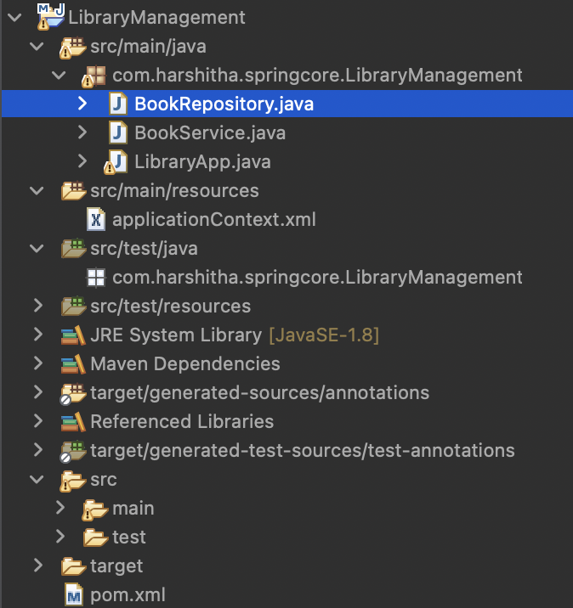

BookRepository.java  
package com.harshitha.springcore.LibraryManagement;

public class BookRepository {

public void getAllBooks()

{

System.***out***.println("fetching all the book records from the repository...");

}

}

BookService.java

package com.harshitha.springcore.LibraryManagement;

public class BookService {

private BookRepository bookrepository;

public BookService(BookRepository bookrepository)

{

this.bookrepository=bookrepository;

}

public void display()

{

bookrepository.getAllBooks();

}

}

LibraryApp.java

package com.harshitha.springcore.LibraryManagement;

import org.springframework.context.support.ClassPathXmlApplicationContext;

import org.springframework.context.ApplicationContext;

public class LibraryApp {

public static void main(String[] args) {

ApplicationContext context = new ClassPathXmlApplicationContext("applicationContext.xml");

BookService bookService = (BookService) context.getBean("bookService");

bookService.display();

}

}

Output:  
